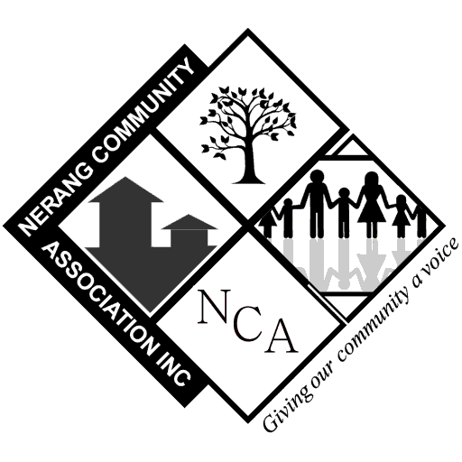

***Nerang Community Association Inc. – Heritage Committee***

##### Friends of the Nerang Heritage Project

***Preece House & Ceramic House***

###### Form 14/A

### 

**Ceramic House** *(c.1919)***:** Originally located near the intersection of Broadbeach Road and Station Street, Ceramic House was built by Robert Ekins Veivers and was named *Ceramic* after the troop ship that carried him to war service in during World War 1.

**Preece House** *(c.1940s)***:** Originally located at the corner of Price and White Streets where the Nerang Library now stands, the Preece house was the home of the Preece family.

### *Please PRINT details clearly*

### **Contact Information:**

### Full Name: __________________________________________________

Street Address: ______________________________________________

Suburb: ______________________________Post Code _____________

Mailing Address: _____________________________________________

Suburb: ______________________________Post Code _____________

E-mail: _____________________________________________________

Home Phone ________________________

Work Phone ________________________

Mobile ________________________

**I would like to be contacted to support:**

🔾 Social events

🔾 Gallery and heritage displays

🔾 Fundraising events – High Teas etc.

🔾 Special events and displays

🔾 Volunteer visitor guides

🔾 Maintenance and restoration work of buildings or timber furniture

🔾 Sponsorship or financial support

Special skills you may have that could support the houses:

______________________________________________________________________________________________________________________________________________________________________________________________________________________________________________________

**Note:**  
Information collected is to facilitate communications between the Heritage Committee and the person/s named above. Information will not be shared with any third party.